1. **1st Place: Organic Management System, American Society of Agronomy-Crop Science Society of America, Soil Science Society of America (ASA-CSSA-SSSA), October 2023**

We presented two research posters at the ASA-CSSA-SSSA International Annual Meeting in October 2023, held in St. Louis, Missouri: **“Evaluation of Labile C and N Indicators of Soil Health After 2 Years of Living Perennial and Annual Cover Crops During Organic Vegetable Production”** and **“Soil Health Characteristics Across a Gradient of Organic Land-Use Intensity in Mid-Missouri.”** This premier conference, hosted by the three largest agricultural societies in the United States, brought together nearly 4,000 researchers to share innovative solutions across environmental and agricultural sciences. The first poster received **first place** recognition and was featured on **Lincoln University’s official social media platforms** and the **Organic Management Systems Discussion Board.**

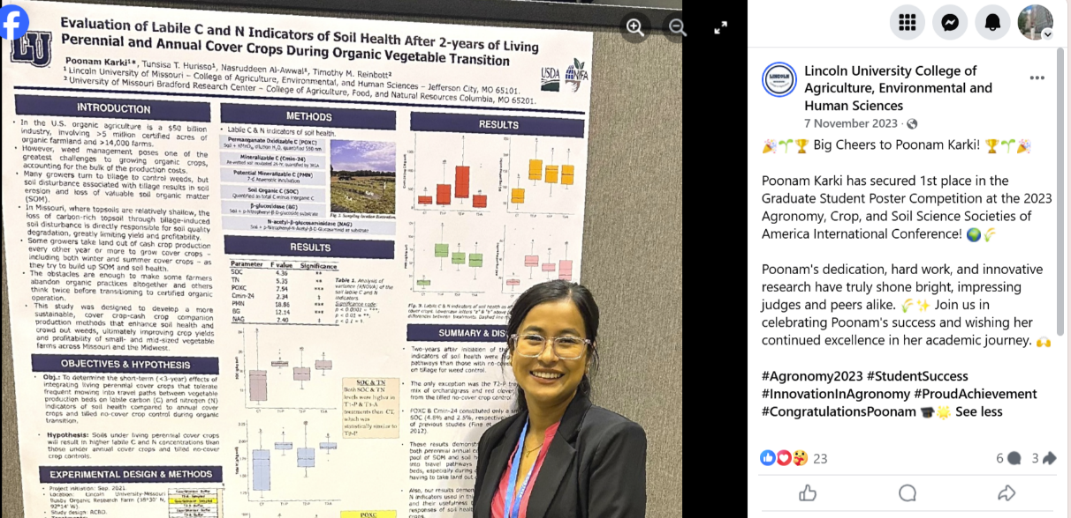

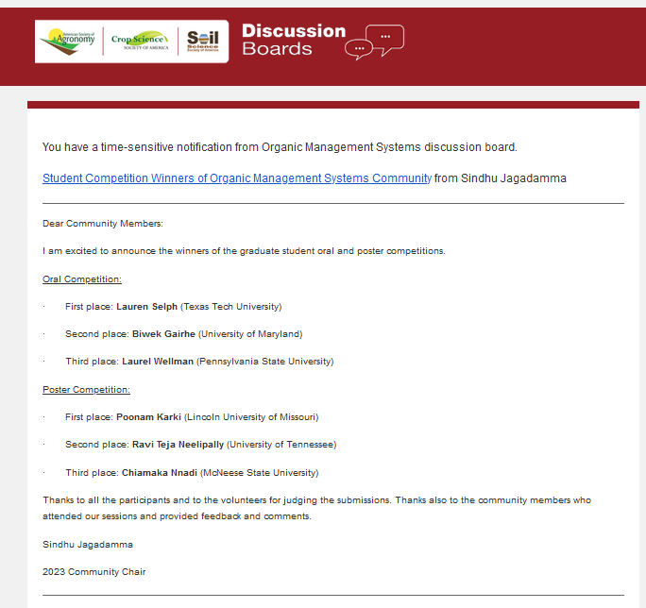

1. **3rd place: 1890 Association of Research Directorate Research Symposium (ARD), April 2024**

I presented a poster titled **“Integrating Living Perennial Cover Crops into Organic Vegetable Systems: Impact on Soil Health and Cover Crop Biomass Production”** at the **1890 ARD Research Symposium** held in Nashville, Tennessee. The symposium, themed “Climate, Health, and Cultivating the Next Generation of Agriculture Leaders: Creating Solutions in Food, Agriculture, and Natural Resources,” brought together over **900 participants** and showcased more than **500 research papers and posters**. My poster was awarded **3rd place** in the **Renewable Energy, Natural Resources, Environment, and Climate Change** category and was also featured on **Lincoln University’s official social media platforms**.

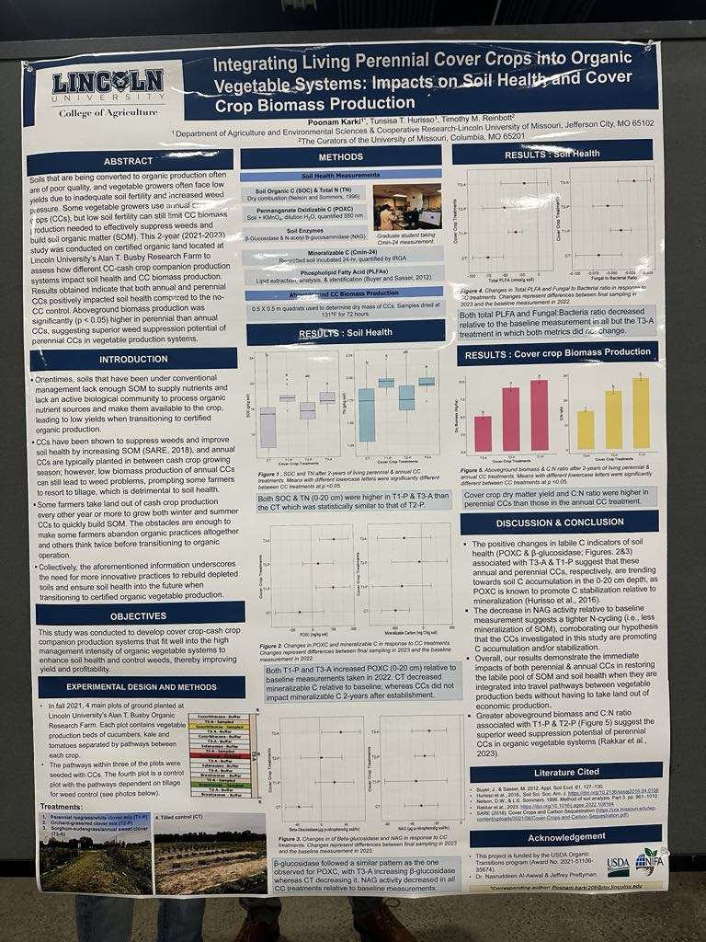 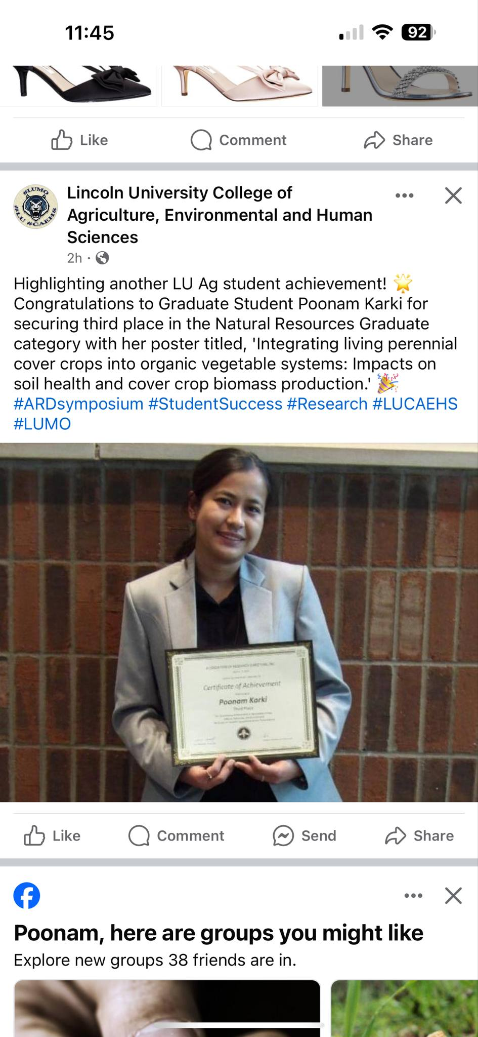

1. **Presenter: MarbleSeed Organic Farming Conference, La Crosse, WI, USA, February 2025**

I presented a poster titled **“Soil Health Comparison of Living Perennial versus Annual Cover Crops During Transition to Certified Organic Vegetable Production”** at the **Marbleseed Organic Farming Conference**, the largest organic farming conference in the United States. Each year, this event brings together regenerative and organic farmers of diverse backgrounds and experiences to explore the latest organic farming methods, build community, and shape the future of the organic movement. My presentation aimed to share research findings and practical insights to support farmers transitioning to certified organic production.

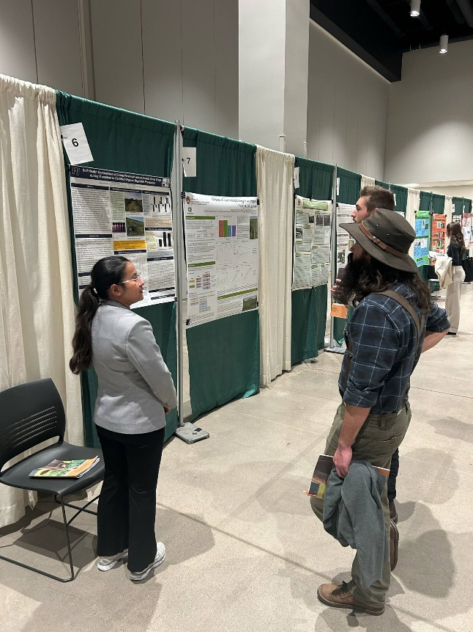 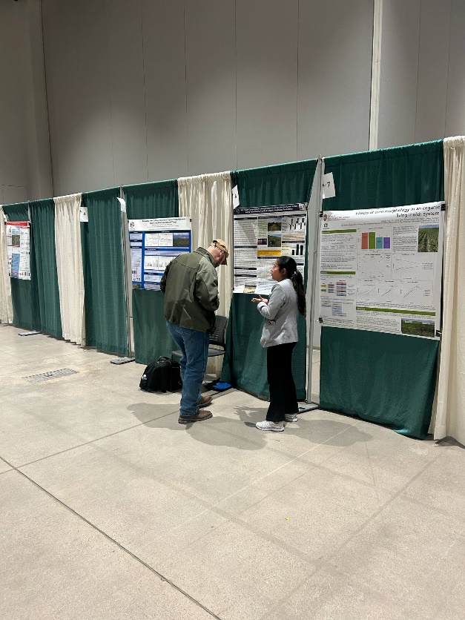

1. **Presenter: Minority and Limited Resources Farmers and Producers Conference, Sikeston, MO, USA**

Our lab came together to demonstrate different tools and their use in soil health testing and how to interpret them in September of 2023 and 2024. Together with the farmers located in the Southeast regions of Missouri, we explored soil respiration, microbial food sources, and soil compaction.

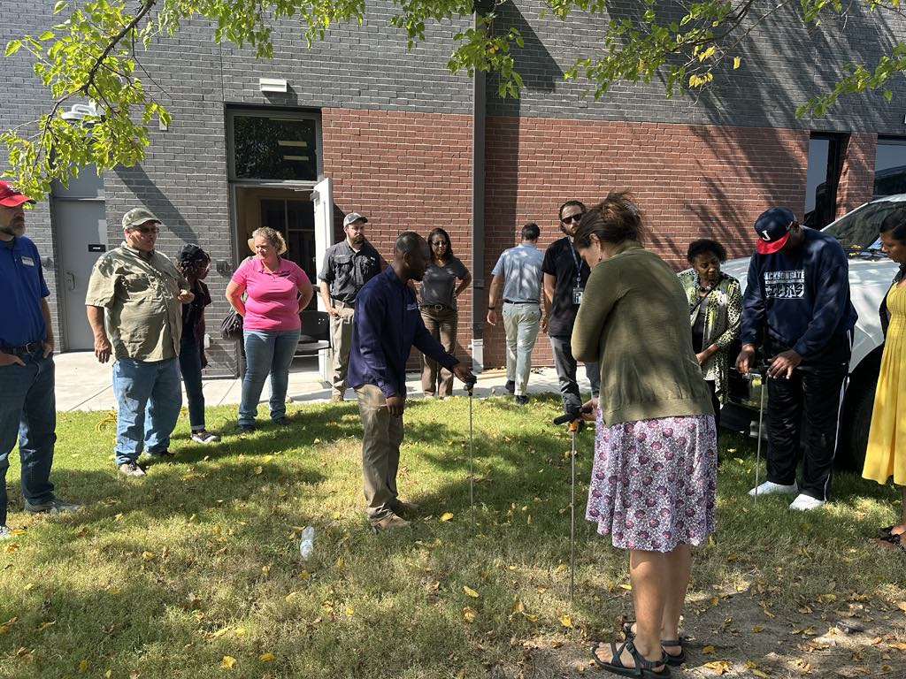 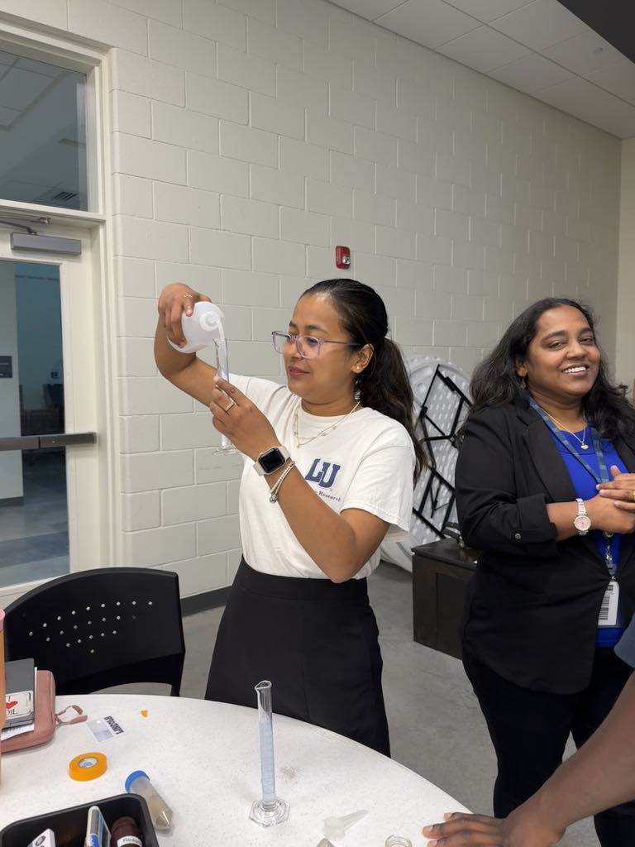

1. **Presenter: Great Plains Growers Conference, St.Joseph, MO, USA, January 2024.**

We presented a poster titled “**Soil Health and Vegetable Yield Responses to Perennial versus Annual Cover Crops in Traffic Pathways**” at the 2024 Great Plains Growers Conference (GPGC) in St. Joseph, Missouri. GPGC is a key annual event for commercial fruit and vegetable producers, specialty crop growers, and hobbyists across the Midwest, drawing attendees from **Iowa, Kansas, Missouri, Nebraska, South Dakota, and beyond**. The conference provides practical, research-based insights from vegetable specialists and experienced growers. Our poster highlighted how the use of perennial and annual cover crops in traffic pathways can enhance soil health and improve vegetable yield, offering guidance to producers seeking more sustainable production strategies.

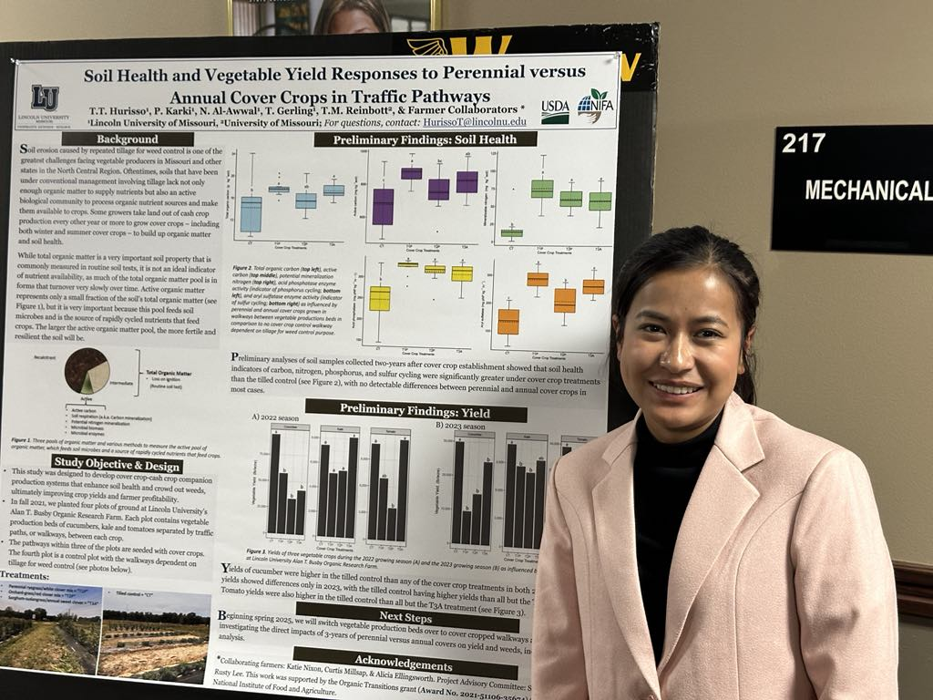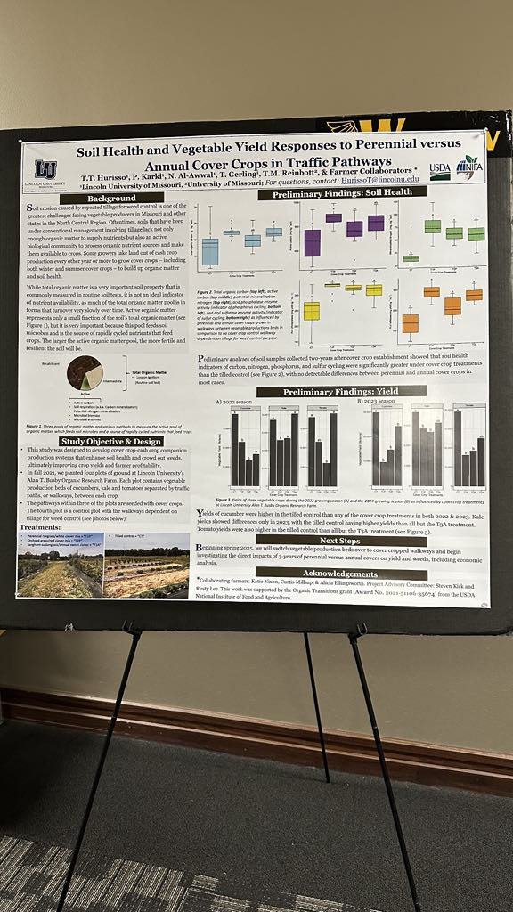

1. **Presenter: 12th National Horticultural Seminar-2021,Kirtipur Kathmandu, Nepal**

I presented a poster titled “**Effect of Maleic Hydrazide and Gibberellic Acid on Growth and Yield of African Marigold (Tagetes erecta L.) CV. Calcuttia Orange**” at the National Horticultural Seminar in Nepal. This seminar serves as a platform to foster the development of horticulture in Nepal and to strengthen linkages with national and international institutions and organizations. The research aimed to evaluate the effects of varying doses of Maleic Hydrazide and Gibberellic Acid on the growth, flowering, and yield of African marigold. The findings contribute valuable information for optimizing production practices and lay the foundation for future research into the productivity of floricultural crops.

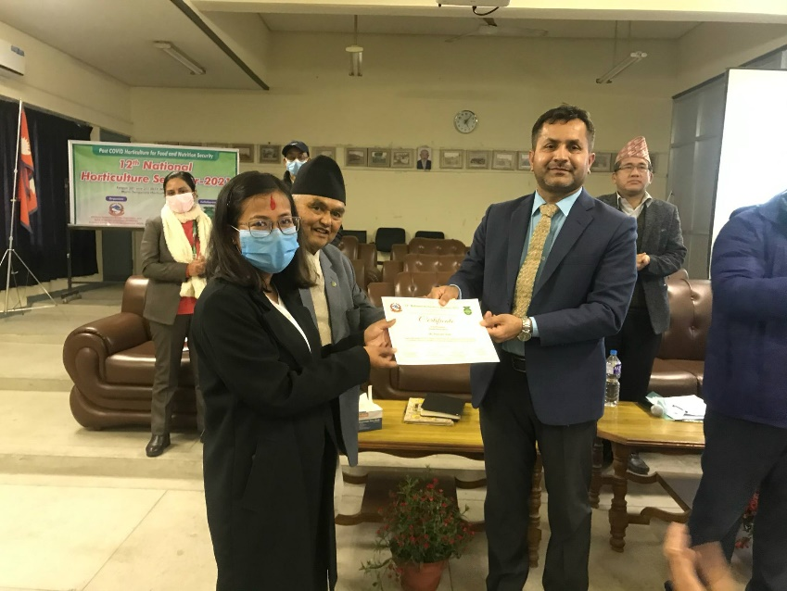 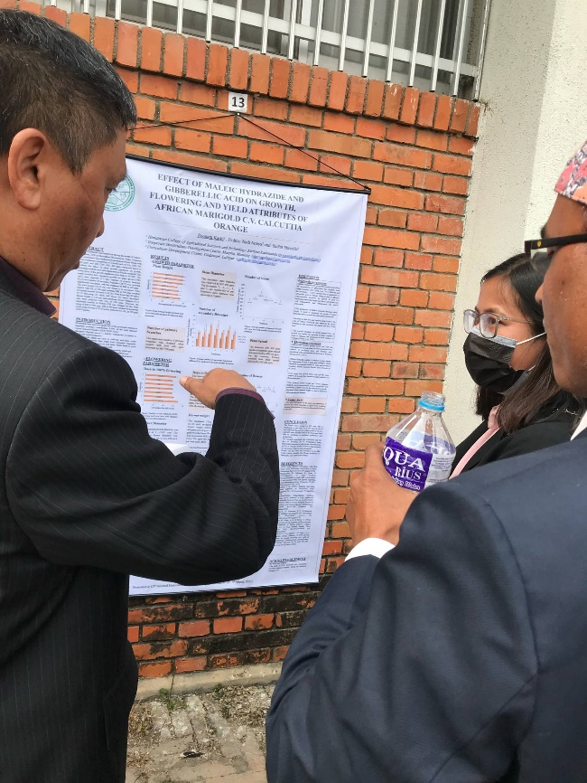

1. **Participant:** **Plant Breeding and Data Analytics Hackathon, Nashville TN, March 2024.**

I I participated in the **2024 Plant Breeding and Data Analytics Hackathon** held in Nashville, TN, where I learned to work with complex datasets to assess phenotypic traits of potential new plant varieties. Through this experience, I contributed to the development of an evaluation system designed to predict which plants will perform best in specific environments—even before they are planted.

This hands-on program enhanced my skills in data analytics, predictive modeling, and plant breeding, enabling me to make informed decisions that support farmers in selecting resilient, high-performing crops, ultimately contributing to more efficient and sustainable agricultural systems.

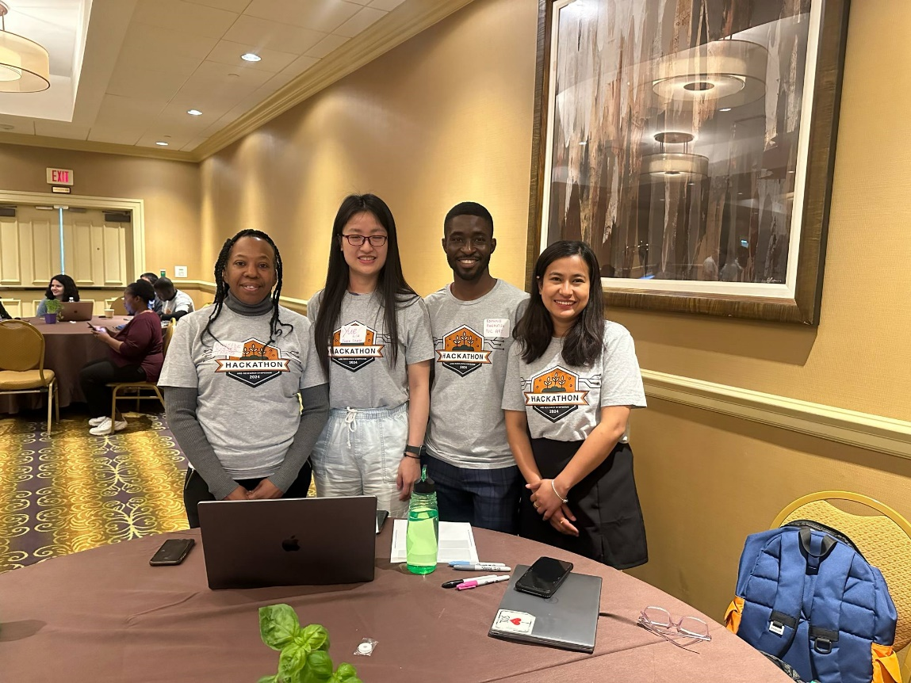

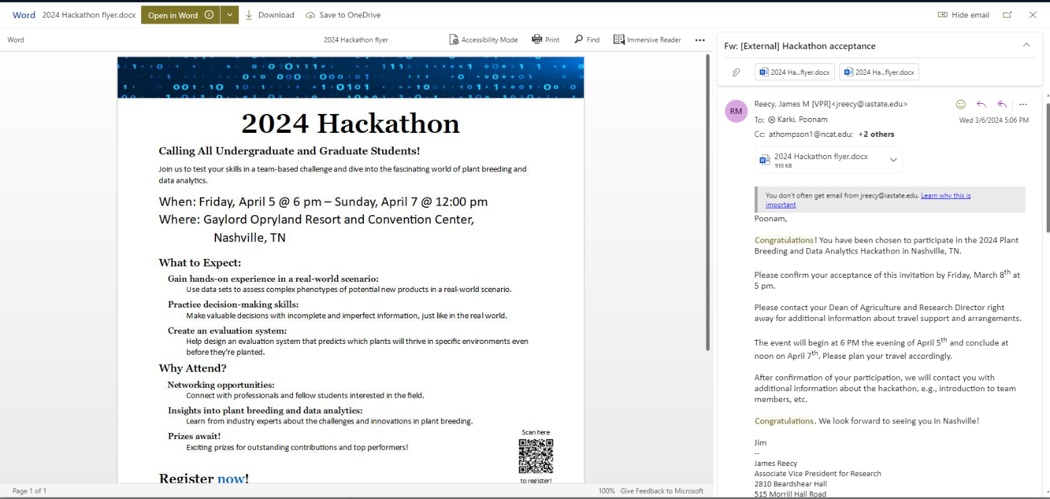

1. **Participant: Missouri Organic Association Annual Conference, MO, USA, February 2025.**

I attended the **Missouri Organic Association Annual Conference**, organized by the **Missouri Organic Association**, which focuses on educating farmers and producers about the value and importance of organic production principles, particularly for specialty crops.

The conference emphasized sustainable practices that preserve natural resources while adding value to farming operations, and provided an excellent platform for networking, knowledge-sharing, and learning about the latest research and innovations in organic agriculture.

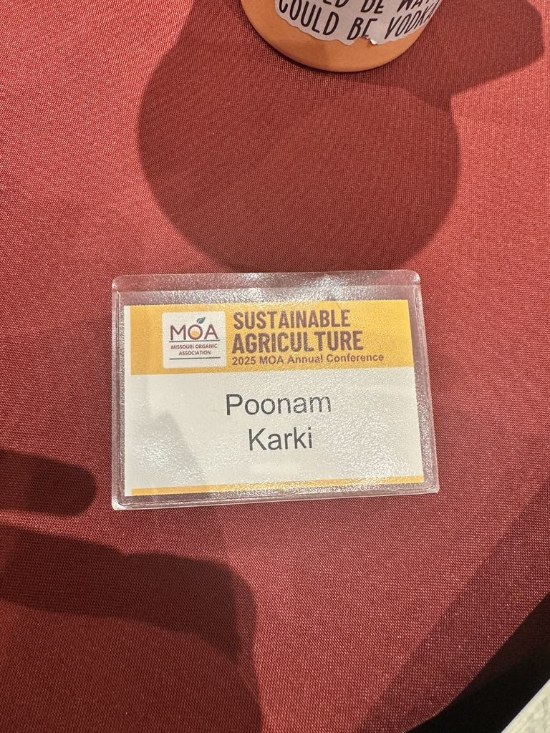

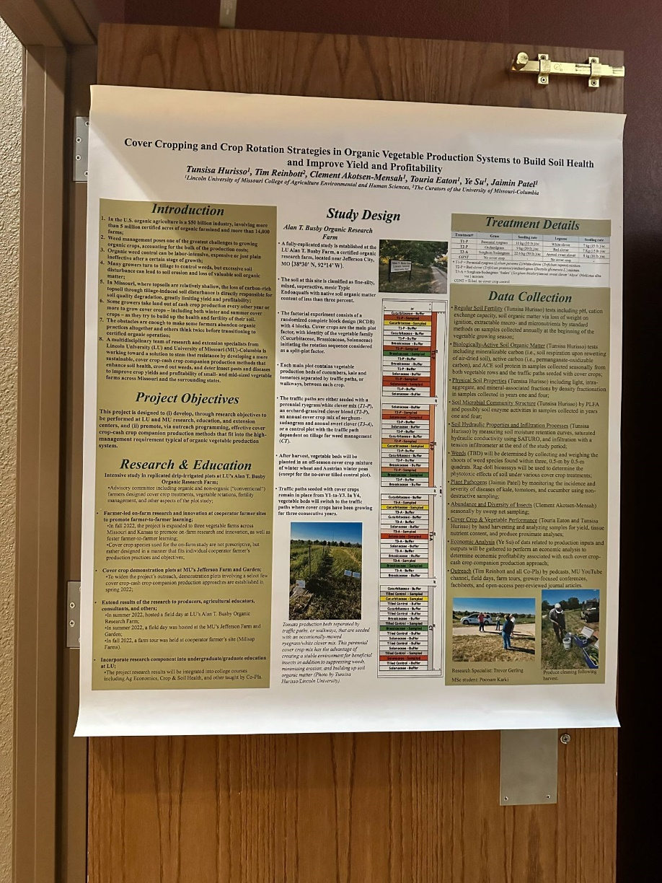

1. **Participant: Great Plains Growers Conference, St.Joseph, MO, USA, January 2025**

I attended the **2025 Great Plains Growers Conference**, a premier event for fruit, vegetable, and specialty crop producers across the Midwest. The conference featured Pre-conference workshops on Hard Cider Production, Nut Orchards, and Marketing Along with Educational tracks covering Tree Fruit, Small Fruit, Protected Culture, Integrated Pest Management, Business Development, and more. This experience enhanced my knowledge in sustainable agriculture practices, market trends, and innovative farming techniques, contributing to my professional development in the field.

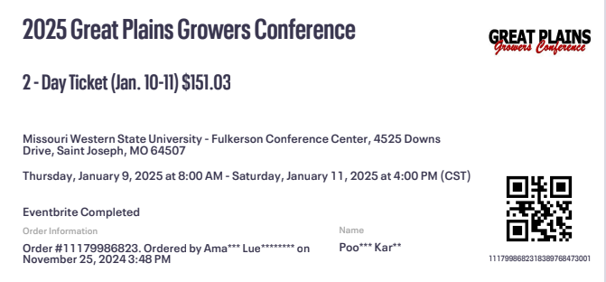

1. **Participant: Lincoln University, USA, September 2025**

I attended the **2023 Hemp Field Day**, I attended the **2023 Hemp Field Day** organized by **Lincoln University**, which focused on the latest research, production practices, and market opportunities in **industrial hemp cultivation**. The event provided valuable insights into **hemp genetics, agronomy, pest management, and post-harvest processing**, and served as a platform for networking with researchers, extension specialists, and growers working to advance the hemp industry in the region.

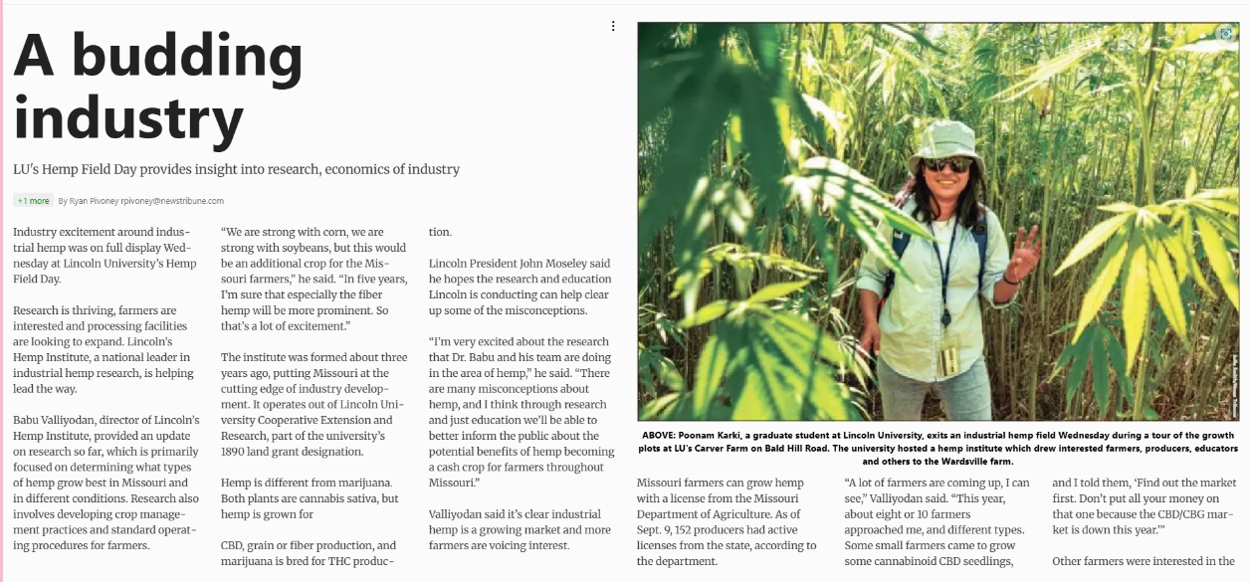

1. **Thesis defense**: **Lincoln University, MO, June 2024.**

I successfully defended my Master’s thesis titled **“Integrating Living Perennial Cover Crops into Organic Vegetable Systems: Impacts on Soil Health and Cover Crop Biomass Production”** on **June 24, 2024**, in front of students, advisors, and professors from **Lincoln University and the University of Missouri**. The objective of my research was to evaluate the feasibility of integrating living perennial and annual grass/legume cover crops into the **traffic pathways** between vegetable production beds. The study aimed to enhance **soil health, reduce weed pressure** and ultimately **increase vegetable yield** during the critical **three-year organic transition period**.

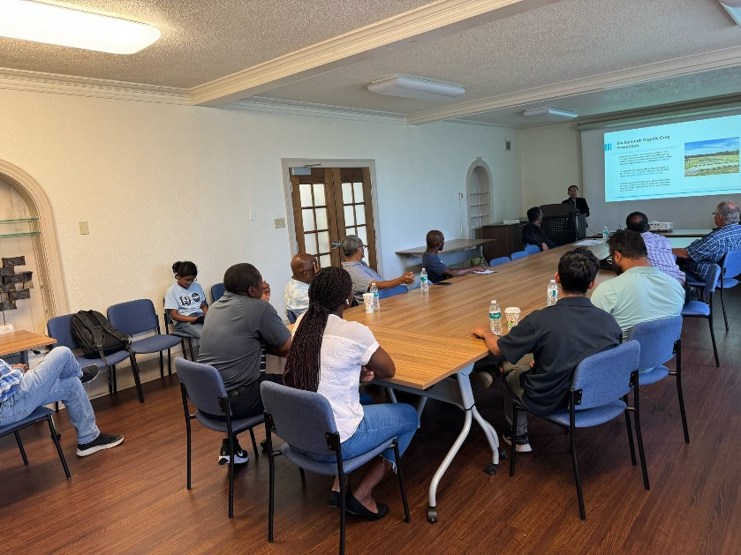

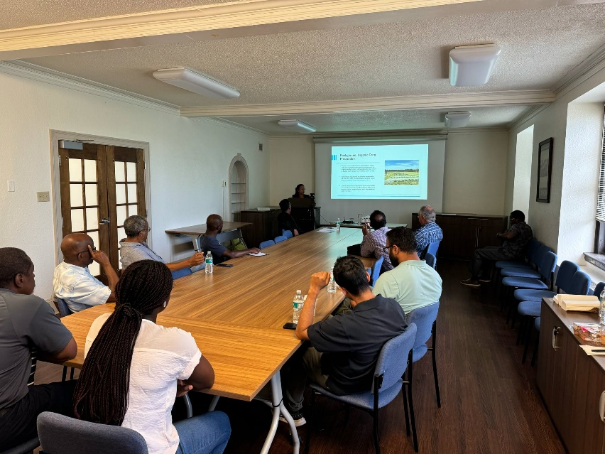

1. **Workshop**: **Himalayan College of Agriculture Sciences and Technology (HICAST), Nepal, January 2020.**

As Vice President of Research and Planning at the **International Association of Students in Agricultural and Related Sciences (IAAS)**, Local Committee HICAST, I organized and conducted a two-day workshop on Organic Inspection and Certification. This workshop brought together leading experts in organic agriculture to share their practical knowledge and insights with the students of HICAST.

The event aimed to enhance student understanding of organic standards, inspection protocols, and certification processes, fostering academic engagement and preparing future professionals for roles in the organic agriculture sector.

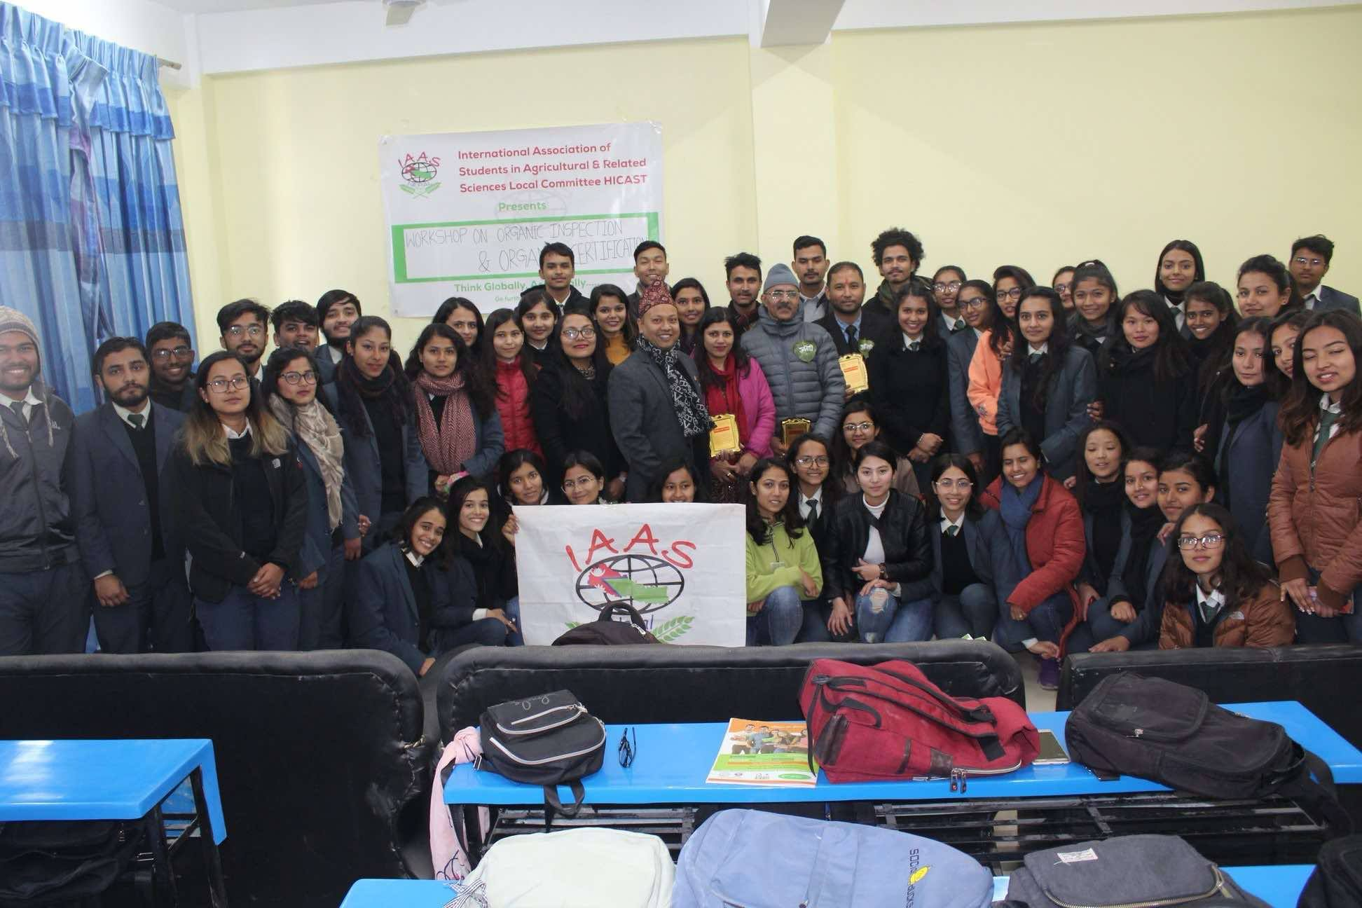

1. **Survey: Kisan Care Pvt. Ltd, Nepal.**

As a **Research Assistant** at Kisan Care Pvt. Ltd., I conducted a comprehensive survey of 500 farmers across the Kathmandu Valley to assess their needs, challenges, and priorities in farming. Based on the findings, I facilitated field-level training sessions aimed at improving farmers' profitability and equipping them with practical skills in sustainable agriculture. These trainings focused on enhancing knowledge in areas such as soil health management, integrated pest control, organic practices, and resource-efficient farming techniques, contributing to the long-term resilience and productivity of local farming systems.

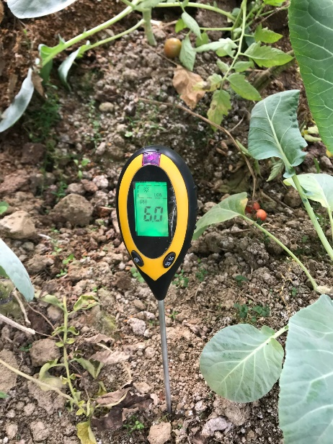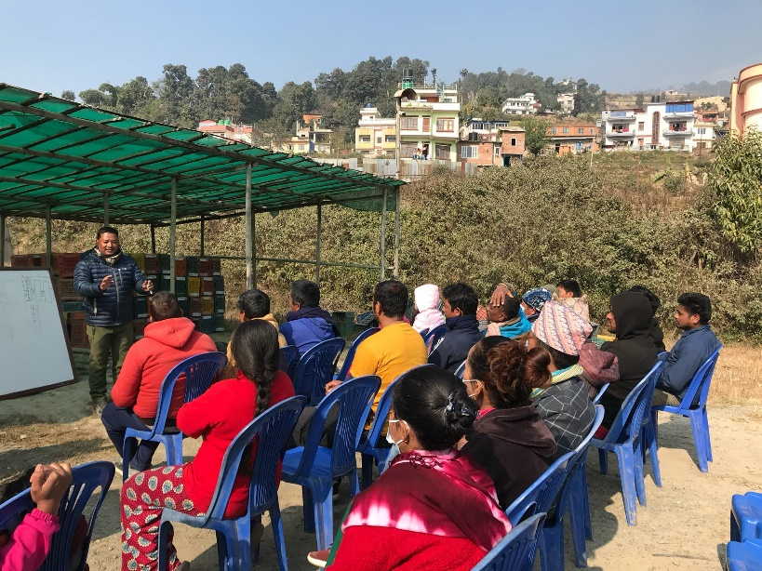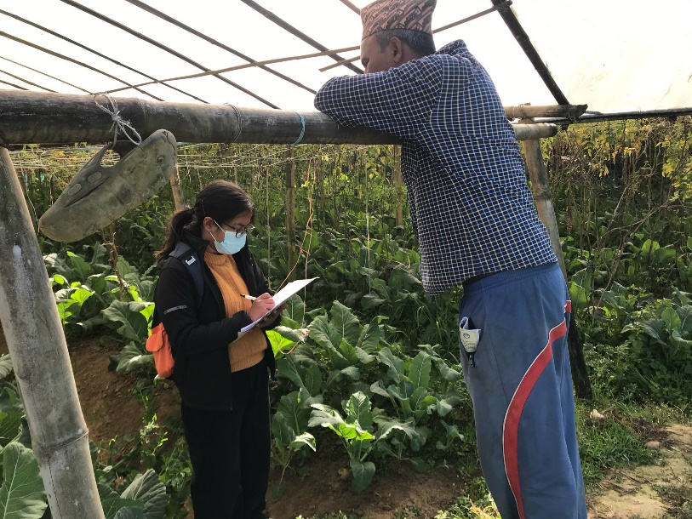

1. **Training: Kisan Care Pvt. Ltd, Nepal**

I participated in a **Training of Trainers** (ToT) on Commercial Vegetable Farming, organized by Kisan Care Pvt. Ltd. in collaboration with **CRS** and the **Farmer-to-Farmer Program**. The training aimed to build local capacity by equipping participants with advanced knowledge and teaching methodologies in commercial vegetable production. It covered topics such as crop planning, integrated pest management, post-harvest handling, and marketing strategies, enabling me to effectively train and support smallholder farmers in adopting sustainable and profitable vegetable farming practices.

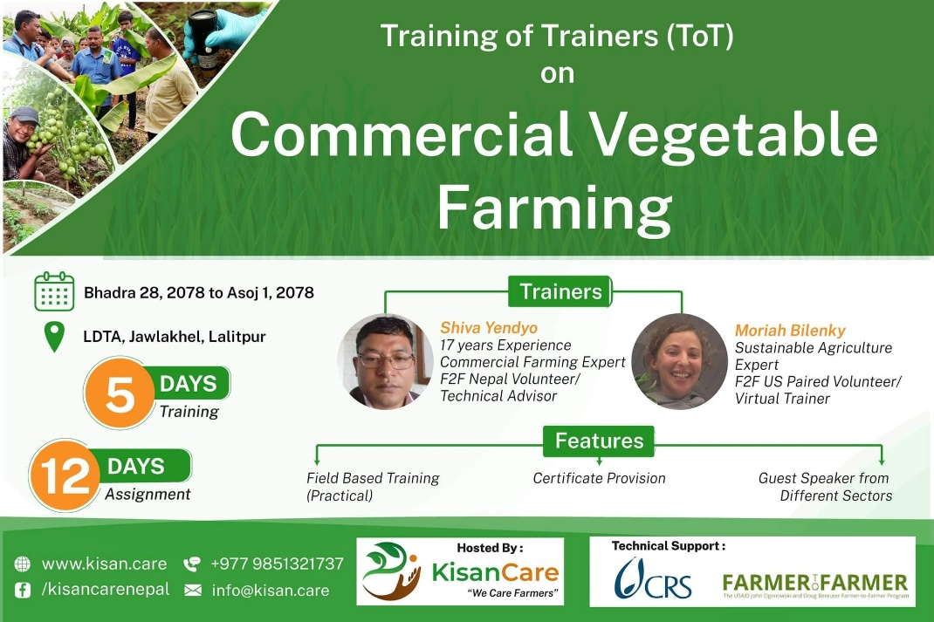

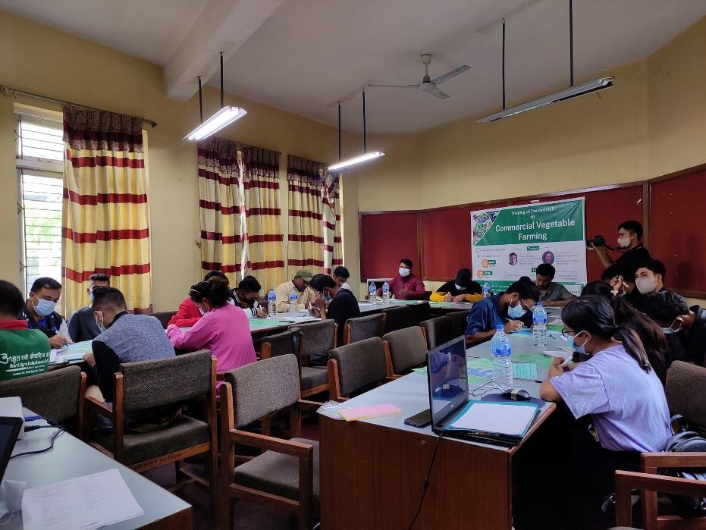

1. **Training: Himalayan College of Agricultural Sciences and Technology (HICAST), Nepal.**

I participated in a series of workshops organized by HICAST , including **Training of Trainers (ToT) courses** on **Poultry Production, Mushroom Cultivation, Plant Propagation, and Nursery Management.**

These hands-on programs enhanced my technical skills and teaching capabilities, equipping me with practical knowledge in small-scale livestock and horticulture systems. The training also prepared me to effectively transfer knowledge to farmers and students, promoting sustainable agricultural practices and entrepreneurship in rural communities.

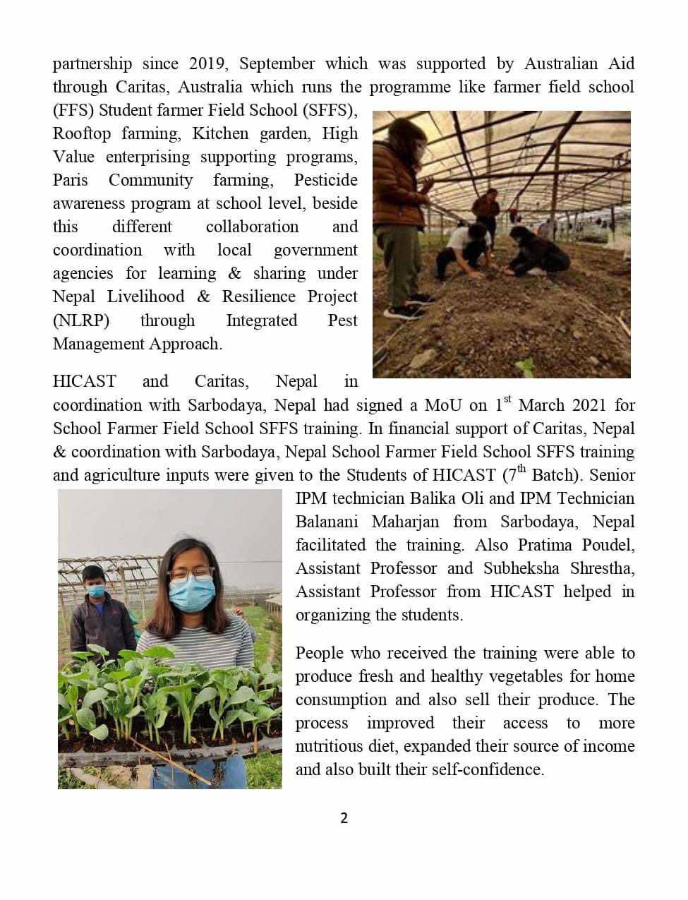

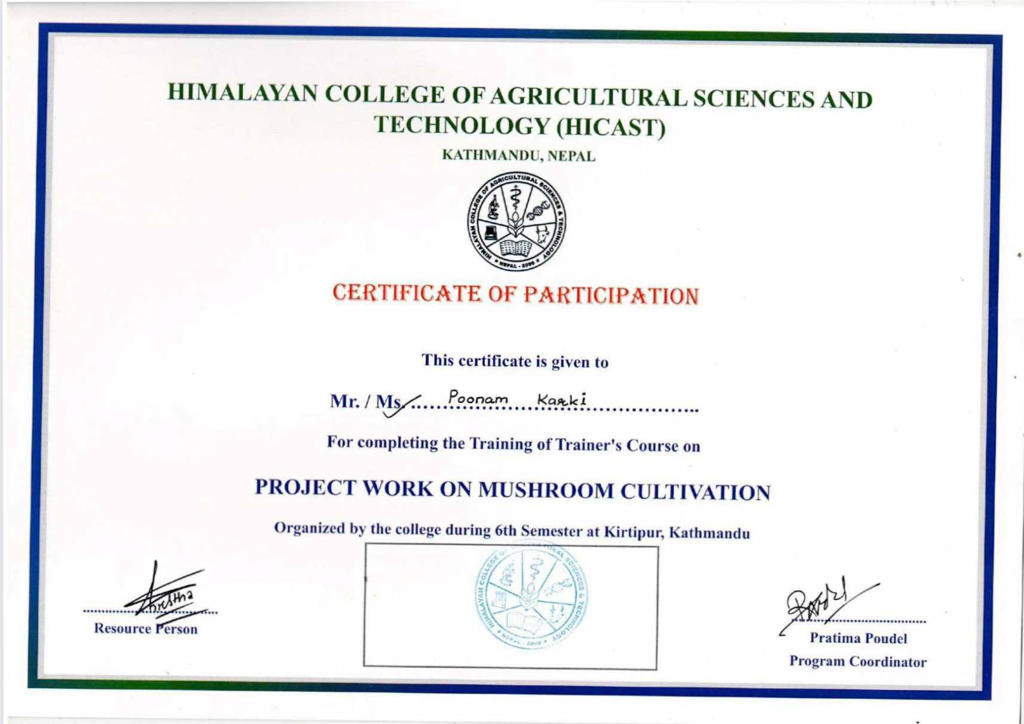

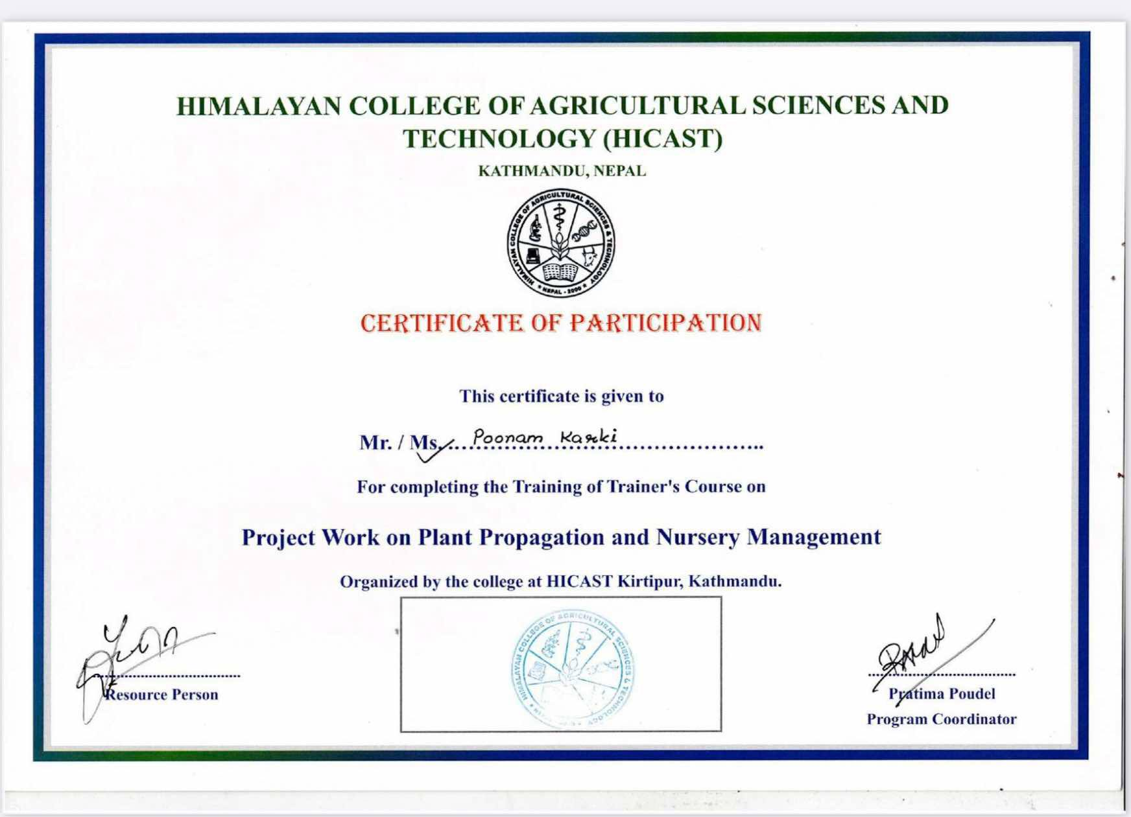

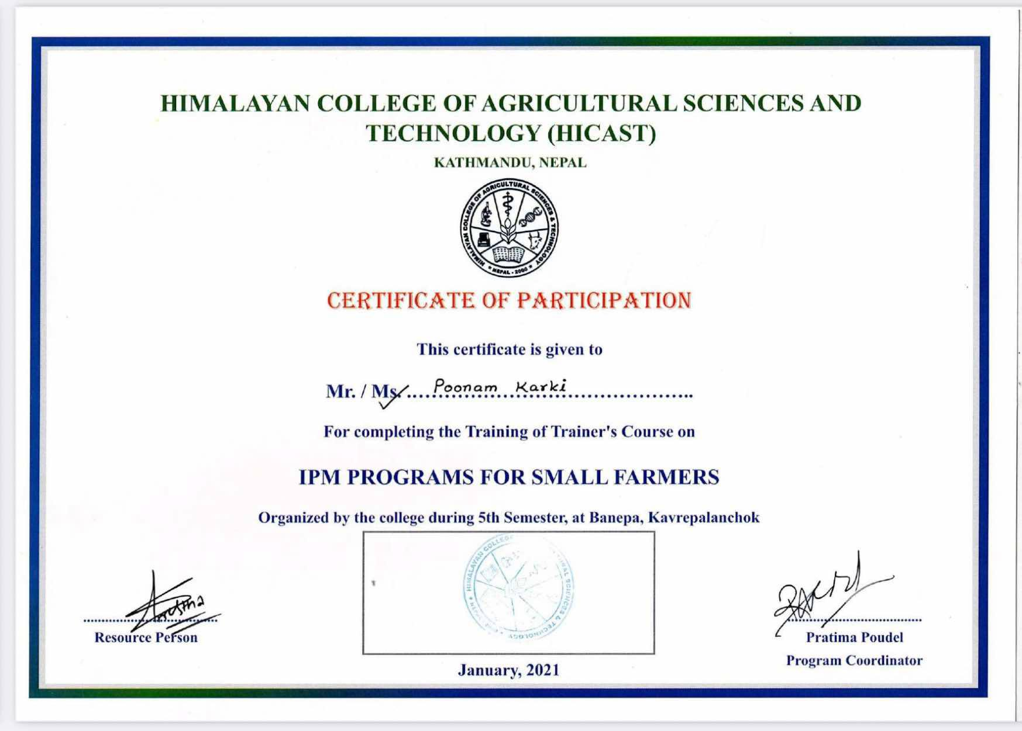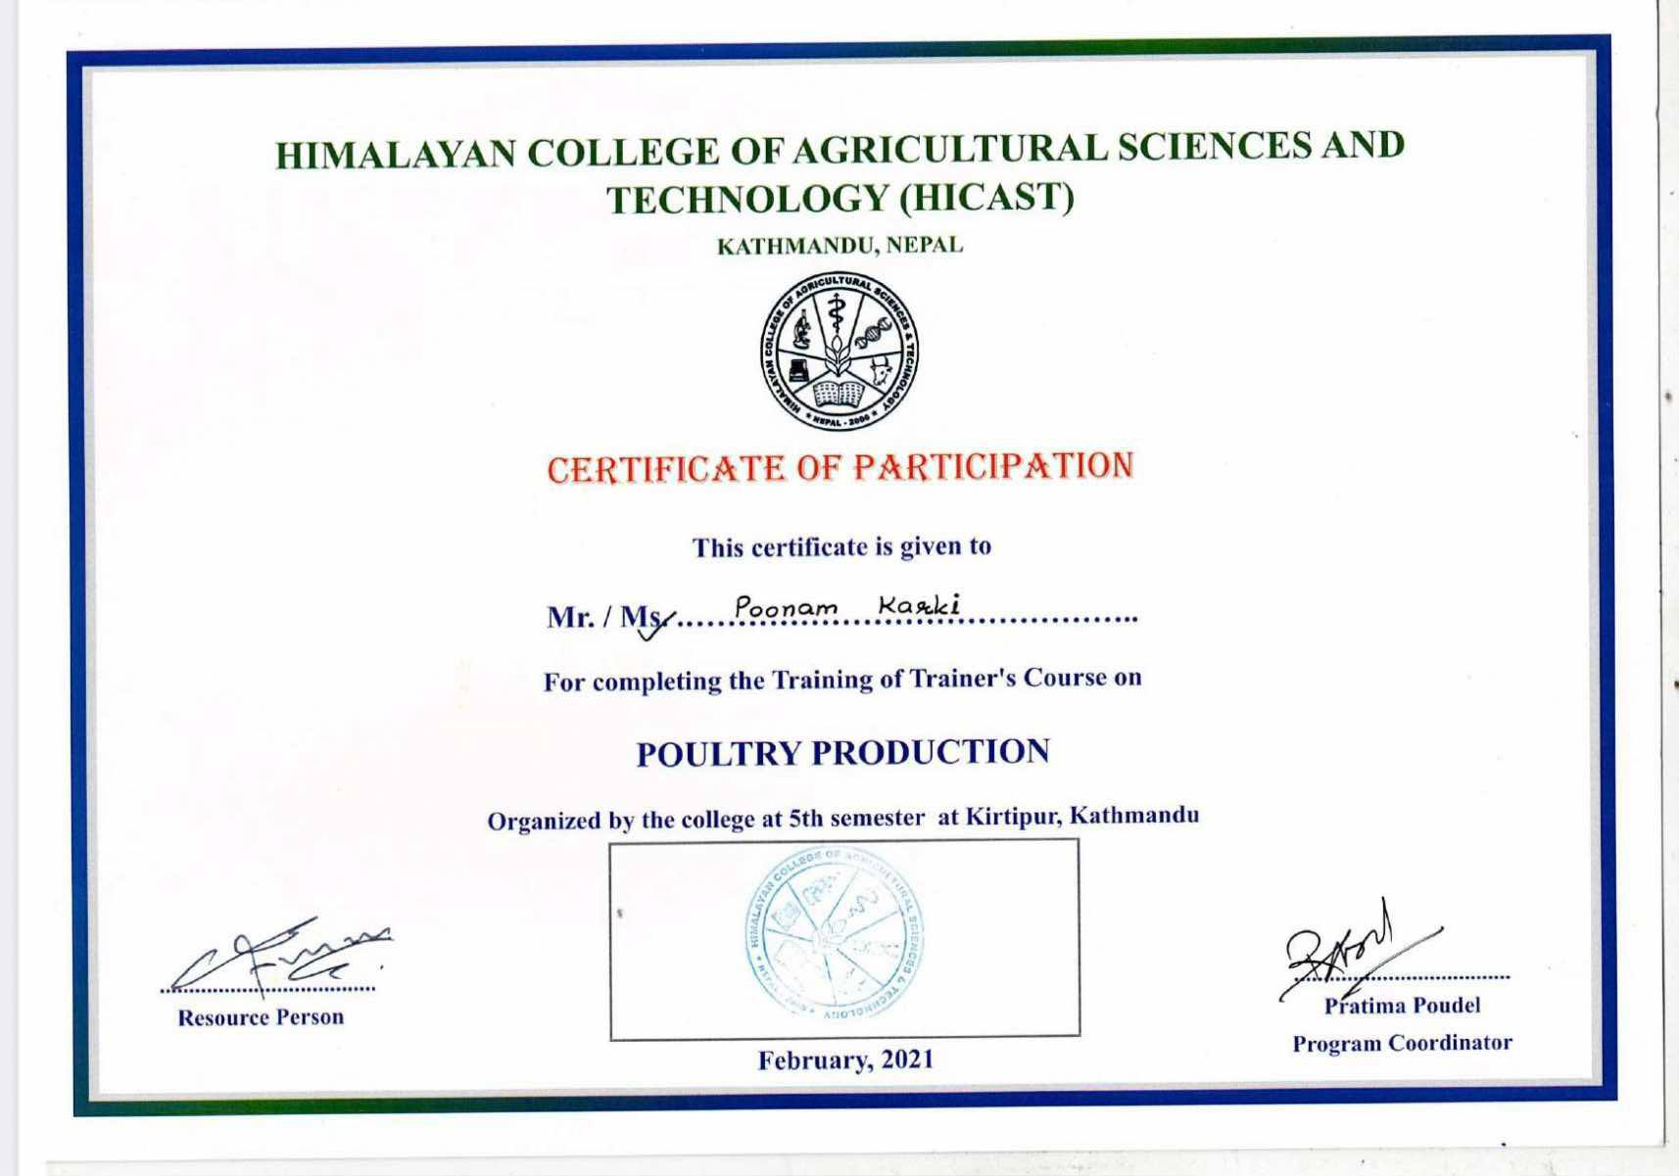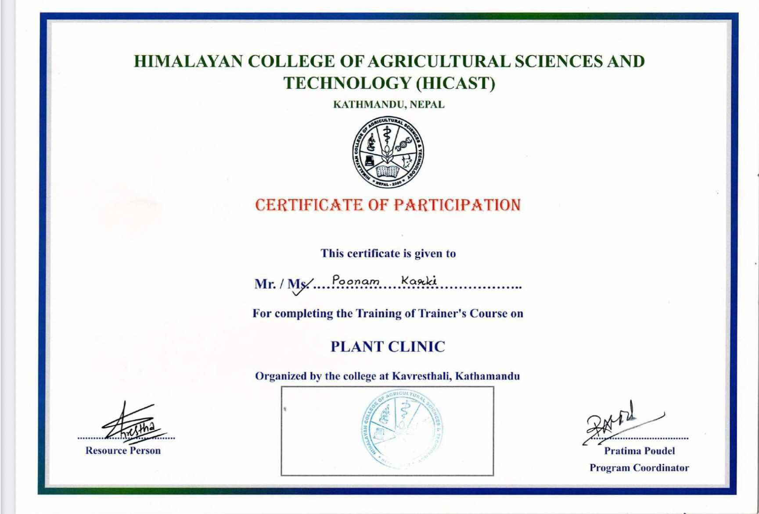

1. **Workshop**: **Lincoln University, October 2022**

As part of our lab's participation in an Extension workshop organized by **Lincoln University**, we engaged with university stakeholders by demonstrating soil health instruments and equipment.

This hands-on session aimed to increase awareness and understanding of soil health assessment tools among farmers, students, and community members, highlighting the importance of monitoring biological, chemical, and physical indicators of soil health in sustainable agricultural practices.

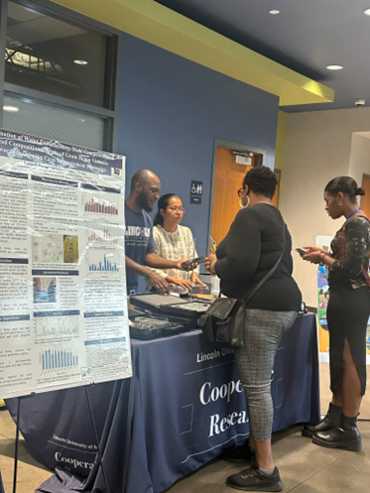 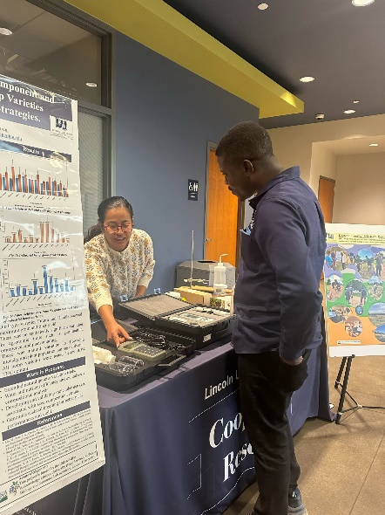

1. **Training: DJI L1 Sensor Operation, Lincoln University, MO, August, 2024.**

I received hands-on training on operating **DJI’s L1 LiDAR sensor** in **photogrammetric mode** at a flight altitude of **50 meters above ground level**, as part of the **Organic Transition Project** at Lincoln University.

This training enhanced my skills in **aerial data collection**, **LiDAR technology**, and **geospatial analysis**, supporting efforts to monitor and assess **field conditions and management practices** in organic transition systems.

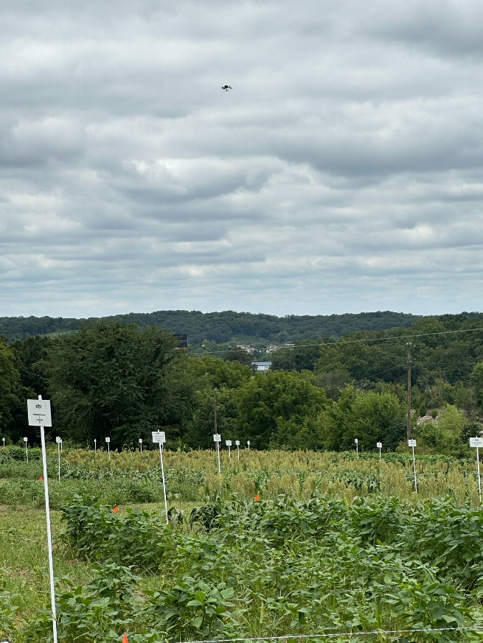 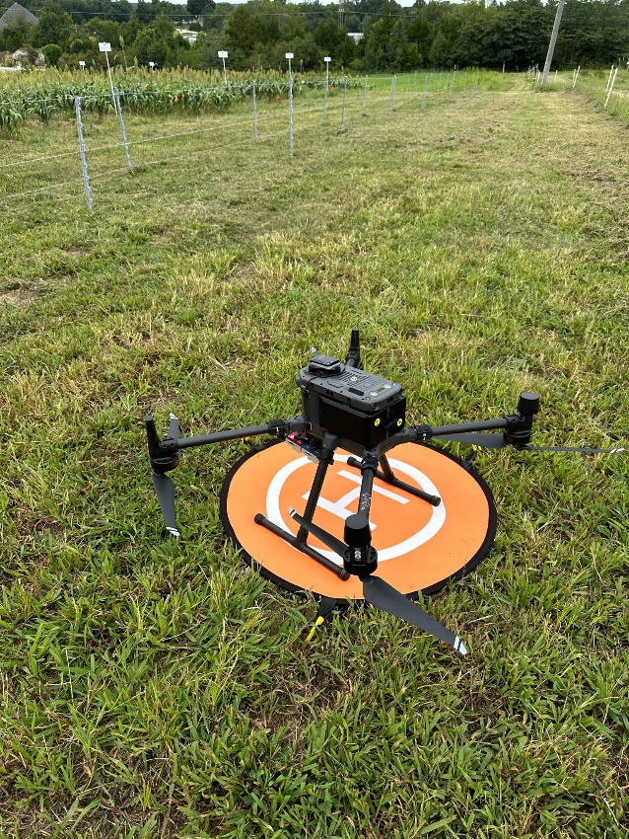

1. **Workshop**: **Lincoln University – Soil Health Outreach Program, Kansas City, MO**

I conducted a community-focused soil health workshop aimed at providing science-based, comprehensive soil health management information to **farmers in and around Kansas City** in September of 2023 and 2024. The program delivered targeted education and outreach services tailored to meet the specific needs of local producers, promoting sustainable farming practices and improved soil stewardship.

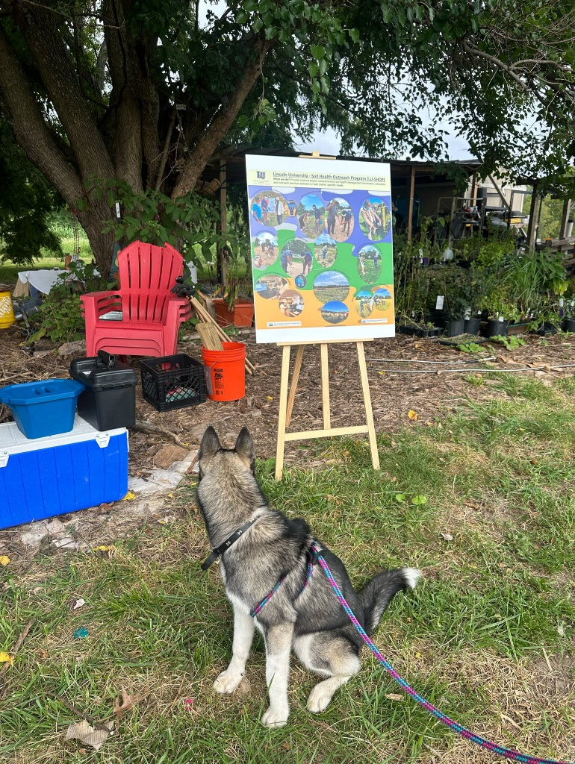 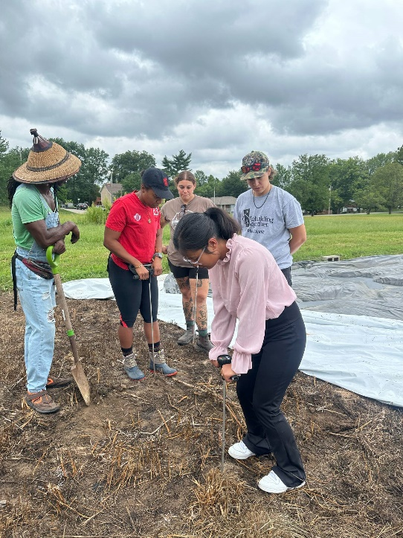

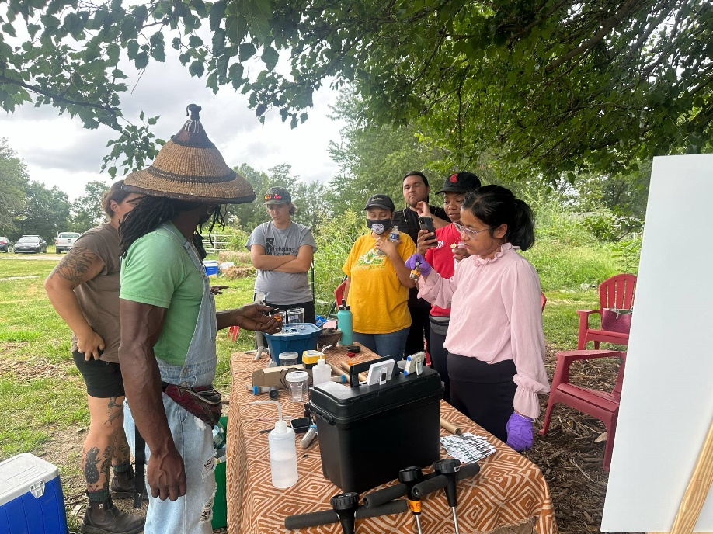

1. **Workshop**: **Farmer Field Day- Lincoln University Allan T. Busby Farm**

We organized a farmer’s field day to showcase our research titled “**The Impact of Annual and Perennial Cover Crops on Soil Health and Vegetable Yield**” to members of the **Missouri Organic Association**. The objective of this event was to demonstrate practical outcomes of our research directly in the field, share science-based insights on soil health improvements and yield responses, and engage with more than **50 organic producers**/ enthusiasts through hands-on learning and open dialogue. The event served as a valuable platform to connect research with real-world farming practices and foster collaborative learning among farmers, researchers, and extension professionals.

